1.Doctype html

2.html tags

3.title tags

4.meta tags

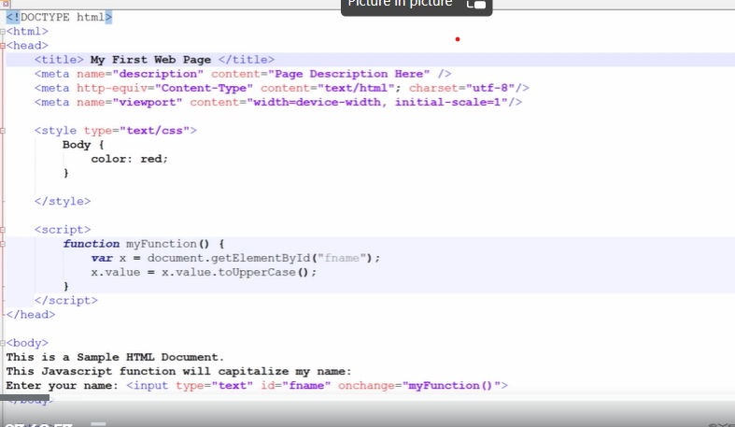

5.text formatting

STRONG – BOLD TEXT

EM – ITALIC

U – UNDERLINE

STRIKE – STRIKING THE TEXT

6.inline formatting

Font face, color, size

7.unordered list – bullets given, ordered list – numeric value given

8.Relative File Referencing – selecting a file from local,

Absolute File Referencing – selecting an image from the web.

9.to insert image – img tag

10.anchor tags – to search for the same page for the content.